System and Software Architecture Description (SSAD)

City of Los Angeles

Applicant Resource Center

Team 09

Team Members and Roles:

Vaibhav Mathur, Project Manager

Preethi Ramesh, Feasibility Analyst

Arijit Dey, Requirements Engineer

Shreyas Devraj, LCP

Gaurav Mathur, Builder

Divya Nalam, OCE

Rakesh Mathur, IIV&V

Image16.png

USC-CSSE

# Version History

| Date | | Author | | Version | | Changes made | | Rationale | |
| --- | --- | --- | --- | --- | --- | --- | --- | --- | --- |
| 10/12/2013 | | Divya, Gaurav | | 1.0 | | First version of the prototype report | | To present the prototype structure as a part of 577 project | |

**TABLE OF CONTENTS**

System Context Diagram 5

Investigator Module 7

Manager Module 8

Reference USCD 9

Support Staff Module 10

Communication Diagram 11

**TABLE OF FIGURES**

Figure 1: System Context Diagram 5

Figure 2: Use Cases - Investigator 7

Figure 3: Use Case : Manager 8

Figure 4: Use Case : Reference 9

Figure 5: Use Case : Support Staff 10

Figure 6: Communication Diagram 11

# System Context Diagram

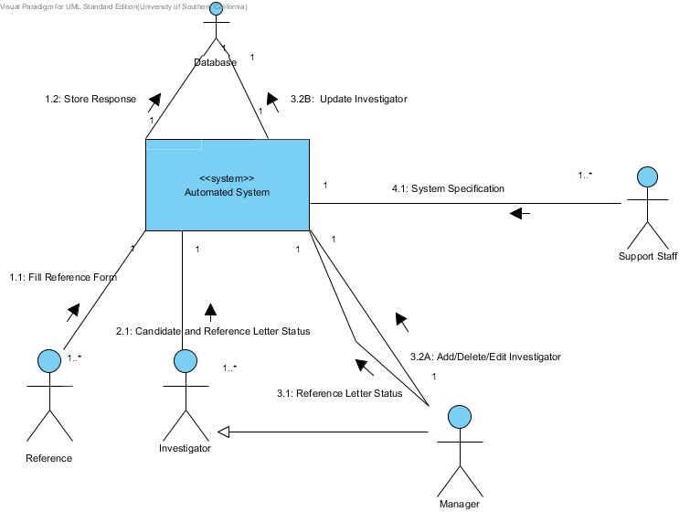

Figure 1: System Context Diagram

### **Details**

|  |  |
| --- | --- |
| Automated System | The Automated System developed |
| Image1.png Reference | Reference of the candidate |
| Image2.png Fill Reference Form | Filling questionnaaire form by the reference |
| Image1.png Investigator | Background Investigation of the applicant |
| Image2.png Candidate and Reference Letter Status | Whether candidate’s reference letters are send to the corresponding reference |
| Image1.png Manager | Manager of the City of LA |
| Image2.png Reference Letter Status | Status of the reference letter |
| Image2.png Add/Delete/Edit Investigator | Manager add/delete/edit investigator |
| Database | Database of the system |
| Image2.png Store Response | Store data in the Database |
| Image1.png Support Staff | Maintain system at the City of LA |
| Image2.png System Specification | Support Staff maintains the specifications of the system |

Use Case Diagram

# Investigator Module

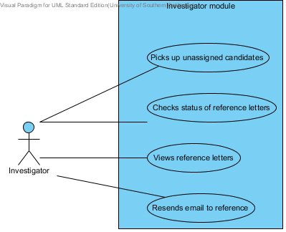

Figure 2: Use Cases - Investigator

## **Details**

|  |  |
| --- | --- |
| Name | Documentation |
| Image1.png Investigator | Background Investigation of the applicant |
| Image10.png Resends email to reference | Capable of resending emails to reference |
| Image10.png Views reference letters | Authorized to read the reference letters |
| Image10.png Checks status of reference letters | Whether reference letters are send to the corresponding reference |
| Image10.png Picks up unassigned candidates | Capable of choosing unassigned candidates for background investigation |
| Image11.png Investigator module | System for the investigator |

Use Case Diagram

# Manager Module

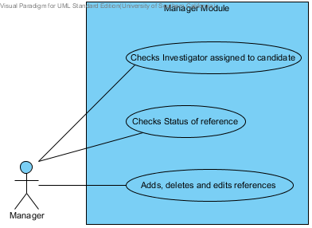

Figure 3: Use Case : Manager

## **Details**

|  |  |
| --- | --- |
| Name | Documentation |
| Image1.png Manager | Manager of the City of LA |
| Image10.png Adds, deletes and edits references | Authorized to add, delete and edit details of the reference |
| Image10.png Checks Status of reference | Capable of checking status of the reference |
| Image10.png Checks Investigator assigned to candidate | Capable of checking investigators assigned to candidates |
| Image11.png Manager Module | System for the Manager |

Use Case Diagram

# Reference USCD

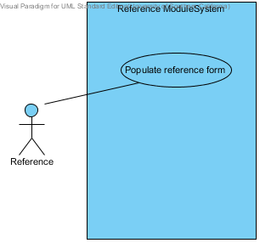

Figure 4: Use Case : Reference

## **Details**

|  |  |
| --- | --- |
| Name | Documentation |
| Image1.png Reference | Reference of the candidate |
| Image10.png Populate reference form | Fill in the reference questionnaire e form |
| Image11.png Reference Module System | System for the Reference |

Use Case Diagram

# Support Staff Module

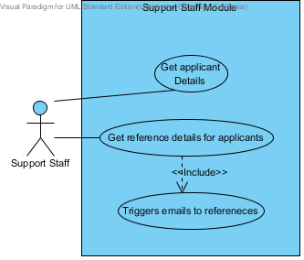

Figure 5: Use Case : Support Staff

## **Details**

|  |  |
| --- | --- |
| Name | Documentation |
| Image1.png Support Staff | Maintain system at the City of LA |
| Image10.png Triggers emails to references | Sends automated emails to the references for the respective candidates |
| Image10.png Get reference details for applicants | Receive details regarding the references of all candidate |
| Image10.png Get applicant Details | Receive questionnaire forms from the candidate |
| Image11.png Support Staff Module | System for the Supporting Staff |

Communication Diagram

# Communication Diagram

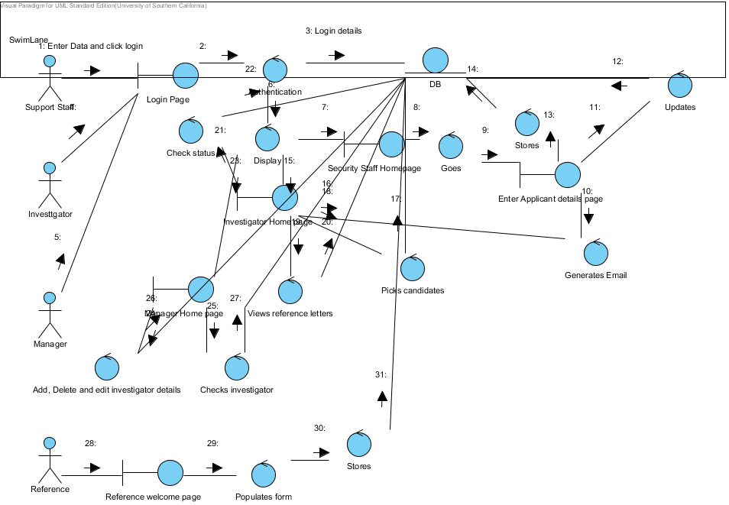

Figure 6: Communication Diagram

## **Summary**

|  |  |
| --- | --- |
| Name | Documentation |
| Image1.png Support Staff | Maintain system at the City of LA |
| Image2.png Enter Data and click login | Enters the login details |
| Image3.png Login Page | Login display screen |
| Image3.png Authentication | Validation of the username and password |
| Image2.png Login details | Username and password sent to DB |
| Image3.png DB | Database |
| Image3.png Display | Screen displaying information to the user |
| Image3.png Security Staff Homepage | Secure homepage for support staff |
| Image3.png Goes | Redirect to another display screen |
| Image3.png Enter Applicant details page | Support Staff enters the details of the candidates |
| Image3.png Generates Email | Support Staff triggers automated email to be sent to the reference |
| Image3.png Updates | The data gets updated in database |
| Image3.png Stores | The data gets stored in database |
| Image1.png Investigator | Background verification of the candidate |
| Image3.png Investigator Home page | Homepage of the Investigator |
| Image3.png Picks candidates | Investigator chooses unassigned candidates for background investigation |
| Image3.png Views reference letters | Investigator views the reference letters of the candidates |
| Image3.png Check status | Check whether reference letters is filled by the reference |
| Image1.png Manager | Manager of the City of LA |
| Image3.png Manager Home page | Homepage of the Manager |
| Image3.png Add, Delete and edit investigator details | Manager add, delete and edit the details of the investigator |
| Image3.png Checks investigator | Manager checks the status of the investigator |
| Image1.png Reference | Reference of the candidate |
| Image3.png Reference welcome page | Homepage of the Reference |
| Image3.png Populates form | Reference fills out the questionnaire form |
| Image3.png Stores | The data gets stored in the database |